**ARUNAI ENGINEERING COLLEGE**

**Department of Computer Science and Engineering**

**Smart Farmer-IOT Enabled Smart Farming Application**

**IBM NALAIYATHIRAN**

# SPRINT DELIVERY – 4

|  |  |
| --- | --- |
| **TITLE** | **Smart Farmer-IOT Enabled Smart Farming**  **Application** |
| **DOMAIN NAME** | INTERNET OF THINGS |
| **TEAM ID** | PNT2022TMID12291 |
| **LEADER NAME** | ADITHYA ARAVIND S |
| **TEAM MEMBER NAME** | ABILASH S  DWARAGESH C  AVINASH M |

**Receiving commands from IBM cloud using Python program** import time import

sys

import ibmiotf.application

import ibmiotf.device import random

## #Provide your IBM Watson Device Credentials

"orgId": "ck2tfo",

"typeId": "NodeMLIC",

"deviceId": "1234"

"token" : "87654321"

# Initialize GPIO def myCommandCallback(cmd): print("Command received: %s" % cmd.data['command']) status=cmd.data['command'] if status=="motoron": print ("motor is on") elif status == "motoroff": print ("motor is off") else :

print ("please send proper command")

try:

deviceOptions = {"org": organization, "type": deviceType, "id": deviceId,

"auth-method": authMethod, "auth-token": authToken} deviceCli = ibmiotf.device.Client(deviceOptions)

#..............................................

except Exception as e: print("Caught exception connecting device: %s" %

str(e))sys.exit()

# Connect and send a datapoint "hello" with value "world" into the cloud as an event of type "greeting" 10 times deviceCli.connect()

while True:

#Get Sensor Data from DHT11

temp=random.randint(90,110) Humid=random.randint(60,100)

Mois=random. Randint(20,120) data = { 'temp' : temp, 'Humid': Humid ,

‘Mois’: Mois}

#print data def myOnPublishCallback(

):

print ("Published Temperature = %s C" % temp, "Humidity = %s %%"

%Humid, “Moisture =%s deg c” % Mois “to IBM Watson") success = deviceCli.publishEvent("IoTSensor", "json", data,

qos=0,on_publish=myOnPublishCallback) if not success:

print("Not connected to IoTF")

time.sleep(10) deviceCli.commandCallback = myCommandCallback # Disconnect the device and application from the cloud deviceCli.disconnect()

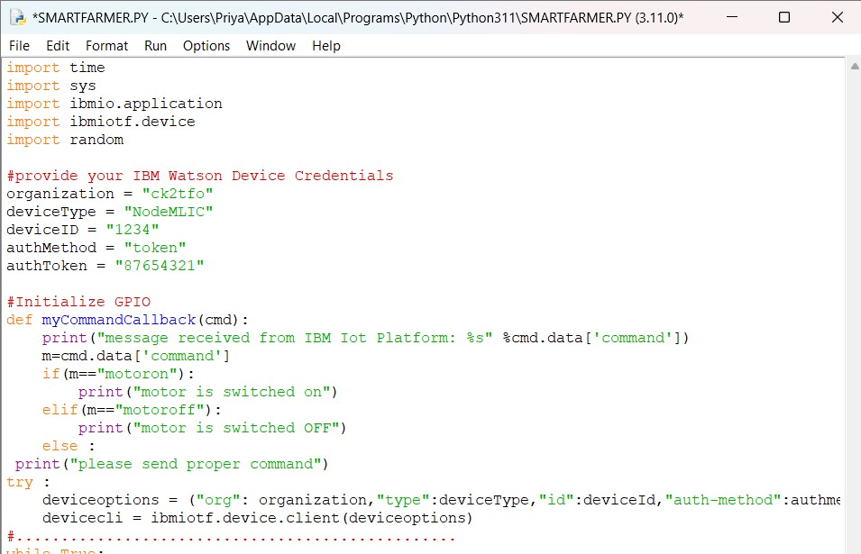

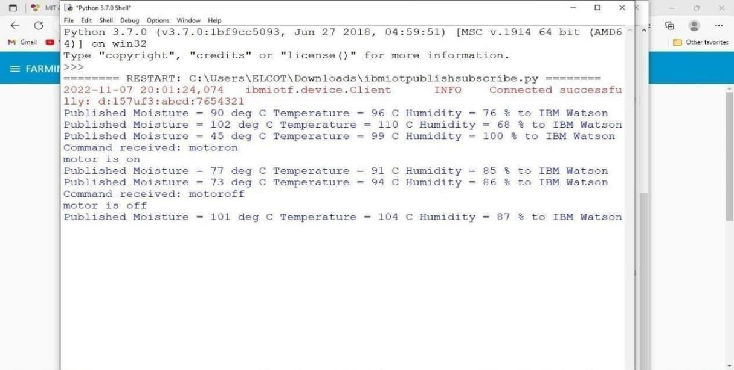

## Flow Chart

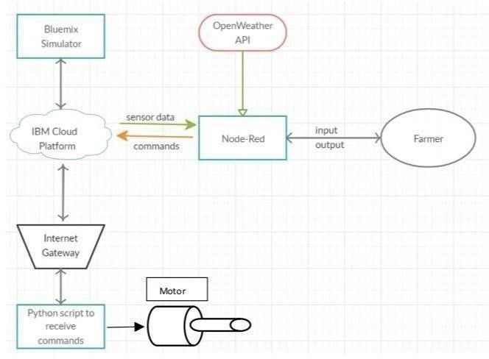

## Observations & Results

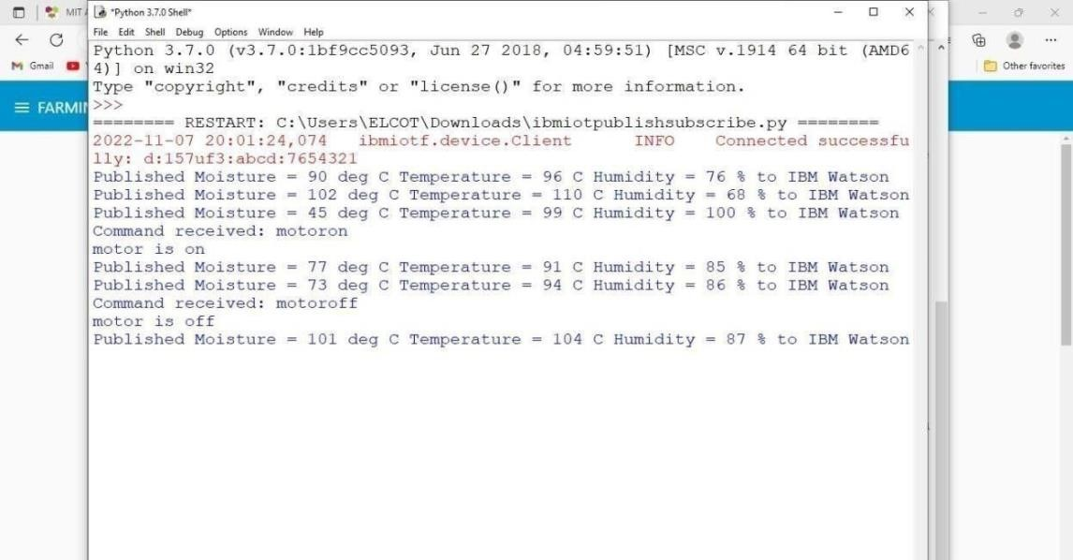

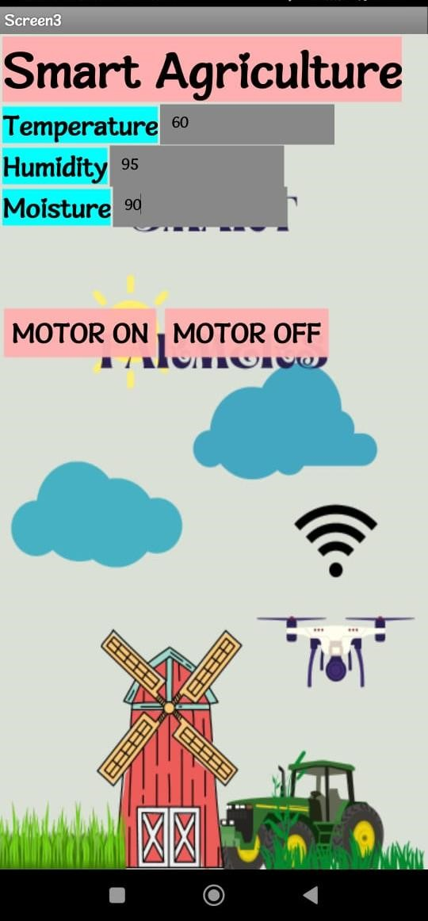

## Temperature

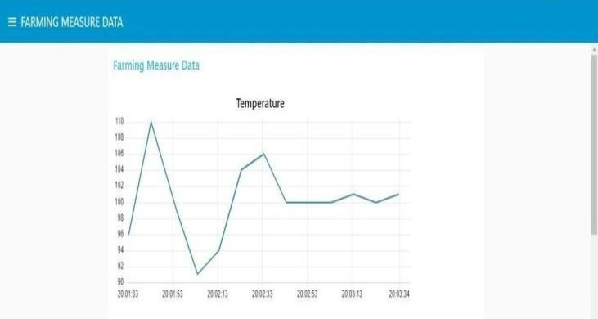

# Humidity

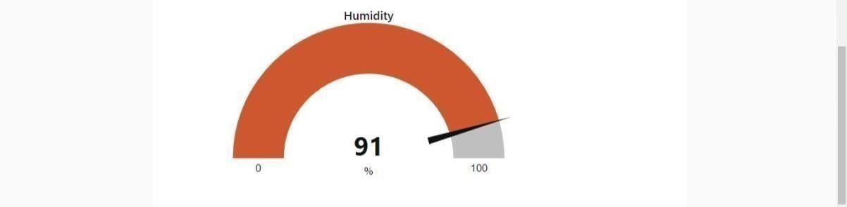

Moisture

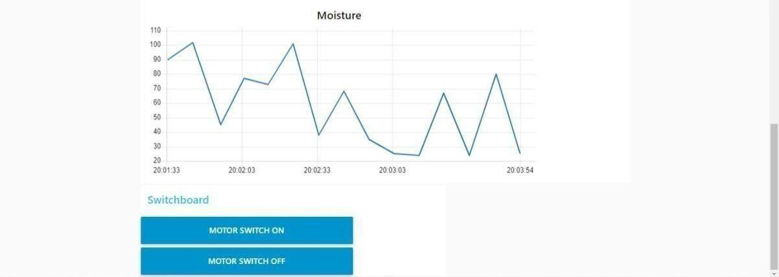

Advantages & Disadvantages Advantages:

* Farms can be monitored and controlled remotely.
* Increase in convenience to farmers.
* Less labor cost.
* Better standards of living.

Disadvantages:

* Lack of internet/connectivity issues.
* Added cost of internet and internet gateway infrastructure.
* Farmers wanted to adapt the use of Mobile App.

## Conclusion

Thus the objective of the project to implement an IOT system in order to help farmers to control and monitor their farms has been implemented successfully.